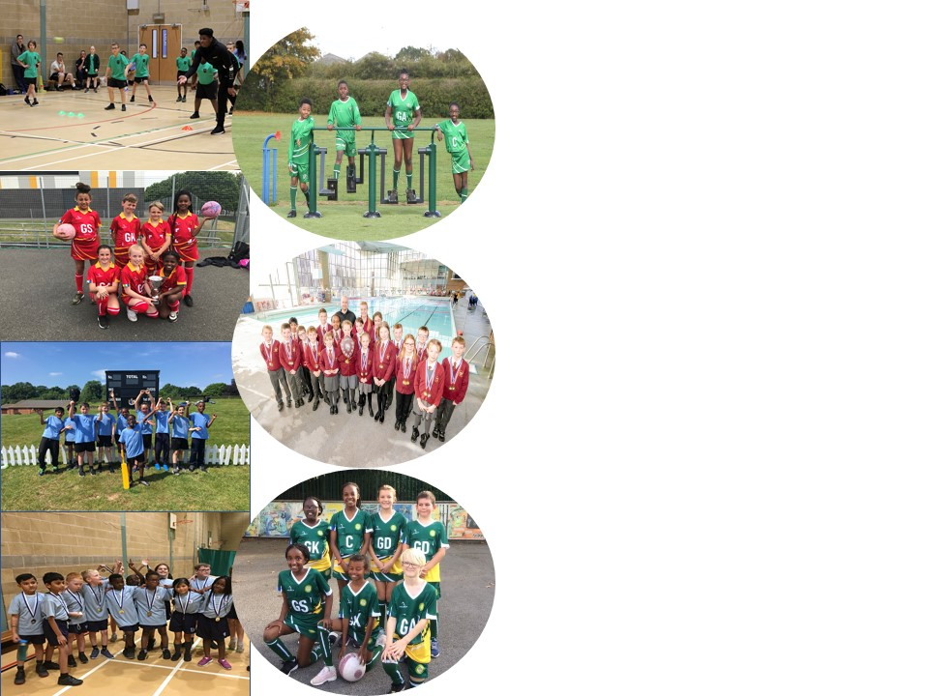
Sacred Heart Catholic Primary School
Sports Funding Impact and Analysis Statement
Following pages are tables showing impact of Government Sports Funding for 2019 - 2020

Sacred Heart Catholic Primary School
Brays Lane, Coventry, CV2 4DW
t: 02476 453314 e: office@sacredheart.coventry.sch.uk w: sacredheart.coventry.sch.uk

Background:

The Government has provided funding until 2020 to provide new, substantial primary school sport funding. This funding is being jointly provided by the Department for Education, Health and Culture, Media and Sport, and will see money going directly to primary school Headteachers to spend on improving the quality of sport and PE for all their children.

The sport funding can only be spent on sport and PE provision in schools. OFSTED will play a significant role in ensuring that schools target this funding in areas which will lead to clear outcomes in raising standards and opportunities in PE and school sport for all children throughout the Primary Phase. All schools receive a lump sum of £16,000 plus an additional £10 per pupil. We are proud of the PE curriculum and sporting opportunities that we have on offer at Sacred Heart Catholic Primary School. We believe that the purpose of Physical Education is to inspire and motivate all children to be active in their lives, enabling them to become physically confident. The importance of living a healthy lifestyle and taking regular exercise needs to be encouraged, alongside the teaching of key fundamental skills. We believe that children should have opportunities to apply the skills they have learnt in competitive situations, either within teams or individually. As a result, key values, including team work, resilience, determination and fair play, can be taught and promoted in an active way. We believe these key values are vital for pupils’ development because lots of these are transferable skills, which can be applied to wider life experiences. Furthermore, we believe that PE plays a fundamental role in educating the whole student. Research supports the importance of movement in educating both mind and body. It also helps the children to make informed choices and understand the value of leading a physically active lifestyle. The benefits of physical education can affect both academic learning and physical activity patterns. The healthy, physically active child is more likely to be academically motivated, alert and successful. In the pre-school and primary years, active play may be positively related to motor abilities and cognitive development. We believe that quality physical education teaching is essential in developing motor skills, physical fitness and understanding of concepts that foster lifelong healthy lifestyles.

At Sacred Heart Catholic Primary School, we ensure that the children receive the highest quality of teaching during their PE sessions. We strive to improve children’s ability and skills in sport as well as having a significant impact on the overall fitness and well-being of the children. We aim for all children to develop positive attitudes towards physical activity ensuring all lessons are accessible by providing a range of different activities to challenge every pupil. We believe in challenging ourselves to always strive to be our best and use our God-given talents to their full potential; we endeavour to instil this personal challenge in our children.

Key achievements to date until July 2020: | Areas for further improvement and baseline evidence of need:
- Dance Team has been successfully established and competed and performed at a variety of large events – Coventry Lights Switch on, GBDO and School Games Got Talent – Started with just 20 children. We had a new group of children join to replace the leaving year 6s, due to the success we now have a waiting list of over 30 children.  - Lunchtime supervisors and staff upskilled in delivering engaging, active play times (playground markings) - 16 Lunchtime supervisors, 25 teaching staff and 10 children play leaders.  - Active Travel reward system embedded within the school (travel tracker) – An average of 45% of the children engage with recording their travel method to and from school. Of these journeys recorded 82% of them use an active travel method (walking, cycling, scooting, skating, parking away from the school and walking in or getting off the bus stops early to walk in).  - We successfully ran a ‘give it a go’ sports week where the children experienced a range of alternative sports from speedway to taekwondo. Many links to sports clubs within our local community and city were made and details passed to the parents. – All children from years 3-6 engaged in 2+ alternative sports. Children from EYFS-Year 2 engaged in 1+ alternative sport. 10 links to external clubs, were sent to all parents from EYFS – Year 6.  - Swimming team (consisting of 20 children from years 3-6) placed 2nd out of the 9 East schools and 4th overall out of 17 East and West schools.  - The year 3/4 girls football team (team of 7) have made it through to the Level 3 finals for the first time.  - It was the first time a Sacred Heart Sportshall team won their heat and made the finals placing 4^{th -} The team consisted of 30 children from across years 5 and 6.  - Sky Blues in the Community Talent ID sessions ran for years 2 and 4 during lunchtimes – 35 children took part.  - Onsite swimming pool offering swimming to all children in the school from nursery to year 6 - Progress data recorded from years 3-6 and certificates awarded. Special certificates of outstanding achievements (physical progress as well as improvements in confidence and attitude) awarded too.  - Over the year LS has attended a Level 5 course in Primary Physical Education Specialism & Subject Leadership to support his teaching practice – 4 of the 6 days attended. Final two days delivered through online training due to Covid19. Extra practical day added to the Autumn term to addressed missed practical elements. Then the certificate will be awarded.  - Donal Kelly Cup/School Games Mark both suspended due to Covid19 – We will be aiming to achieve Gold next year as we met all of the criteria this year before the award was suspended.  - Bronze Youth Sport Trust Quality Mark awarded May 2020 | We have focussed a lot this year on improving the quality and range of sporting opportunities the children get to engage with, moving forward we want to continue to provide these opportunities but now place more of our focus on the quality of our curriculum P.E provision. The action plan created following receiving the YST bronze quality mark will be used to help guide our developments and areas of improvement.  Student Voice is collected during the Summer Term. Due to Covid19 this was not possible. This will be collected retrospectively during the new academic year.  - Continue to ensure the array of extra-curriculum sporting opportunities are provided  - Raise the level of engagement from 45% in the recording of active travel through the travel tracker – classes who were not engaging will be targeted. Travel tracker monitors will be appointed in each class.  - To continue to develop the quality of curriculum P.E lessons  - Embed the updated P.E curriculum map  - Focus on upskilling teachers and support staff in their delivery of curriculum P.E – 100% of the teacher and support staff surveys raised that teachers and support staff’s confidence in the planning, delivery and assessment of P.E is low  - Implement a new system for assessing the children’s progress in their curriculum P.E lessons. This has been developed through PE Leads and a MAC initiative.  - Introduce and embed processes that allow the children to become more aware of their physical progress, understand the intent of each lesson and the sequence of lessons and allow them to comment on and review their progress and personal bests  - Continue to track participation and use this as an integral document to identify those who are least active so they can receive targeted support

Meeting national curriculum requirements for swimming and water safety | Please complete all of the below:
What percentage of your current Year 6 cohort swim competently, confidently and proficiently over a distance of at least 25 metres?  N.B. Even though your children may swim in another year please report on their attainment on leaving  primary school. | 58%
What percentage of your current Year 6 cohort use a range of strokes effectively [for example, front crawl, backstroke and breaststroke? | 40%
What percentage of your current Year 6 cohort perform safe self-rescue in different water-based situations? | 40%
Schools can choose to use the Primary PE and Sport Premium to provide additional provision for swimming, but this must be for activity over and above the national curriculum requirements. Have you used it in this way? Yes/No | £4000

Academic Year: 2019/20 | Total fund allocated: £19,590 | Date Updated:
Key indicator 1: The engagement of all pupils in regular physical activity – Chief Medical Officer guidelines recommend that primary school children undertake at least 30 minutes of physical activity a day in school |  |  |  | Percentage of total allocation:
 |  |  |  | %
Intent | Implementation |  | Impact
Your school focus should be clear what you want the pupils to know and be able to do and about what they need to learn and to consolidate through practice: | Make sure your actions to achieve are linked to your  intentions: | Funding allocated: | Evidence and impact: | Sustainability and suggested next steps:
- To continue to improve the engagement in purposeful active play at break and lunchtimes.  - To embed a range of sporting activities within the school and to support teachers in delivering high-quality P.E lessons. To provide children with high-quality dance and gymnastics opportunities and engage children at lunchtimes in physically demanding dance activities.  - To improve teachers’ knowledge and skill set of how to incorporate active learning methods into their core subjects such as reading, writing and maths. Resulting in children engaging in more physical activities throughout the day.  - Additional catch up swimming lessons for Year 6 pupils. Those who need more support to meet the 25m target. | Play leaders to be appointed and receive the play leaders’ qualification and training.  All play leaders, lunch time supervisors and teachers to be given training by ESP in effectively using the playground markings.  Employment of TA with P.E specialism to support in embedding the range of sporting activities that children of all ages are exposed to. Employment of dance teacher to deliver a range of dance and gymnastics opportunities.  P.E SLE to provide support and guidance to teachers on active learning methods to increase children’s physical movement throughout the school day.  Children identified from lessons that need more targeted support. Currently 58% of the year 6s can swim 25m+ and 40% can swim a range of strokes and perform self-rescues (October 2019). | £1000  Jade Falconer (Elite Dance Academy) - £480 per month (x9) = £4320  N/A  £1000 | The training was high quality which all found very useful. As a result, the lunch time supervisors and staff at breaktimes are more confident in leading a range of purposeful activities as well as play leaders at lunchtime. 16 Lunchtime supervisors, 25 teaching staff and 10 children play leaders were all trained.  Teachers provided with support to improve their P.E teaching. Children received high quality dance and gymnastics opportunities. Children more physically engaged at lunchtimes through dance.  This was planned for the end of the Spring term but couldn’t take place due to Covid 19.  This was planned for the Summer term but couldn’t take place due to Covid 19. | Provide refresher training sessions to all following the prolonged gap in provision due to Covid 19. Train up a new batch of younger play leaders.  Develop a set of play cards that give reminders of the different activities they can lead to act as a reminder and encourage the children to self-select what they’d like to play.  At the moment Jade’s role will not be continuing next year. We will work to train up some of the sports leaders to deliver engaging dance lunchtime sessions and upskill the teachers with their practise.  This will be planned into the next academic year. Support is also being timetabled for SE to support the teachers on a more regular basis.  Dependent on the levels of proficiency of our year 6s next year, plan this in if needed.
Key indicator 2: The profile of PESSPA being raised across the school as a tool for whole school improvement |  |  |  | Percentage of total allocation:
 |  |  |  | %
Intent | Implementation |  | Impact
Your school focus should be clear what you want the pupils to know and be able to do and about what they need to learn and to consolidate through practice: | Make sure your actions to achieve are linked to your intentions: | Funding allocated: | Evidence of impact: what do pupils now know and what can they now do? What has changed?: | Sustainability and suggested next steps:
- To raise the children’s aspirations to achieve and continue to be motivated to raise their expectations of their capabilities, certificates, stickers, medals and other rewards/incentives will be purchased to award children’s sporting successes.  - To promote more of a ‘buzz’ and excitement towards P.E lessons appropriate, engaging equipment to be purchased so that all can participate. By having appropriate, engaging equipment we hope to see a decrease in behavioural issues and an increase in participation.  - To visibly raise the profile of the frequency of P.E and sporting opportunities taking place. | Engaging incentives and rewards to be purchased throughout the year.  Audit of equipment to be done in line with the P.E provision map, appropriate, engaging equipment to be purchased.  Staff P.E kit to be purchased. | £600  £1000  £400 | Children’s sporting success’ have been rewarded. Children feel proud of their achievements and appreciate the recognition we give them, helping them to create long-lasting memories. Children’s motivations to succeed have improved.  Equipment purchased to support the high-quality teaching of curriculum and extra-curriculum sporting opportunities.  All staff have Sacred Heart branded P.E kit. You can easily visibly see when a class will be taking part in P.E from the staff’s attire. The attire also ensures the staff are dressed appropriately to be able to lead physical demonstrations in their lessons, whilst modelling safe, sporting attire to the children. The uniform also helps us to be easily recognised when outside of our school environment at fixtures etc… | This recognition and praise of their successes will continue.  We will continue to audit our equipment and add to our resources to continue to be able to provide engaging sporting opportunities.  We will continue to ensure any new staff have the appropriate kit and all staff’s kit is updated where necessary.

Key indicator 3: Increased confidence, knowledge and skills of all staff in teaching PE and sport |  |  |  | Percentage of total allocation:
 |  |  |  | %
Intent | Implementation |  | Impact
Your school focus should be clear what you want the pupils to know and be able to do and about what they need to learn and to  consolidate through practice: | Make sure your actions to achieve are linked to your intentions: | Funding allocated: | Evidence of impact: what do pupils now know and what can they now do? What has changed?: | Sustainability and suggested  next steps:
- In order to improve progress and attainment of all pupils, the Romero Catholic Academy have appointed a PE & Wellbeing Coordinator to review sporting facilities, create coaching skills matrix, marketing, communication and upskilling of staff. | CPD for staff delivered by PE & Wellbeing Co-ordinator to address needs highlighted in teacher confidence survey and increase confidence within teachers to deliver PE across the school. | - £4,500 | PE & Wellbeing Coordinator has help delivered training & support to teachers delivering PE within specific year groups throughout the year. Focusing on the specific planned curriculum areas for PE and also preparing year groups for School Game Competitions.  Teacher Year Group Support:  - Year 2 – Ball Skills  - Year 3 – End Ball  - Year 6 – Cross Country  - Year 5 – Gaelic Football  The PE and wellbeing coordinator has helped to support our PE Lead with developing a structure for assessment for PE and skill progress to enhance the curriculum. PE Co-Ordinator has support with MAC sporting festivals and pre competitions to support our children going to events. Events Attended:  - Indoor Cricket – Year 5  - Indoor Athletics – Year 5/6  - Cross Country – Cancelled due to Weather.  - Other event had been scheduled for Spring 2, Summer 1 & Summer 2 but cancelled due to COV19 outbreak.  Through the COV19 outbreak The PE & Wellbeing Co-Ordinator has supported the Wellbeing of our children through online Wellbeing Assemblies for all Romero schools and also a program of Teacher challenges for our home school leaners. | To continue work with the PE & Wellbeing coordinator to develop our curriculum to encourage CPD for teachers taking ownership for School Games events.  To trial and develop cross curriculum activities to help increase physical activity levels within the school.  To enhance provision of alternative sports activities either during lunchtimes or afterschool. This will include more of a strategic approach for event for SEN pupils
Key indicator 4: Broader experience of a range of sports and activities offered to all pupils |  |  |  | Percentage of total allocation:
 |  |  |  | %
Intent | Implementation |  | Impact
Your school focus should be clear what you want the pupils to know and be able to do and about what they need to learn and to  consolidate through practice: | Make sure your actions to achieve are linked to your intentions: | Funding allocated: | Evidence of impact: what do pupils now know and what can they now do? What has changed?: | Sustainability and suggested  next steps:
- To provide the opportunity for children to dance and perform in a range of professional environments such as theatres.  - To be exposed to and engage with a wider range of alternative sports.  - To improve water confidence, safety and swimming ability to all our pupils from nursery-year 6. | Transport for the dancers to and from these venues (too many children for the mini-bus).  Sessions to be ran by a range of external providers from netball, to cycling speedway to taekwondo.  An on-site swimming pool to be brought in so that all children can be introduced to swimming and develop the knowledge of how to be safe around water. | £200  £120  £4000 | All 20 children in the team, from years 4-6, were able to engage with a range of incredible opportunities due to us being able to provide the transport for them.  The children thoroughly enjoyed engaging in a range of different sports. All links with these local sports clubs and facilities were shared with the parents so that their children can continue to engage with these activities outside of school hours. Parents on the LAC praised this.  By bringing the pool onsite we are able to control the quality of the provision provided to our children, track their progress as they move throughout the school and ensure that all children are able to engage with swimming opportunities. By cutting down the travelling we are maximising the swimming time available. | We will continue to provide this support next year as the impact of these events on the children’s self-esteem and confidence has been amazing.  We will continue to look into providing opportunities that engage the children in a range of alternative sports.  This provision has been a great success over the last two years and we will continue to provide this.
Key indicator 5: Increased participation in competitive sport |  |  |  | Percentage of total allocation:
 |  |  |  | %
Intent | Implementation |  | Impact
Your school focus should be clear what you want the pupils to know and be able to do and about what they need to learn and to  consolidate through practice: | Make sure your actions to achieve are linked to your intentions: | Funding allocated: | Evidence of impact: what do pupils now know and what can they now do? What has changed?: | Sustainability and suggested  next steps:
- To engage a range of children in wide range of competitive sports and competitions.  - Facilitate assess of sporting opportunities across the city. | Membership and participation in Catholic Sports Association Competitions, School Games Competitions and Romero transition activities.  Supply cover to release staff members to prepare and accompany the children to competitions.  Lease minibus to provide the required transport to attend sporting events, swimming programmes and active learning opportunities. | - £600  £1000  £444 per month | All Catholic Sports competitions taken part in and 7 of the School Games events (up to lockdown). 2 School Games finals made one level 2 and one level 3, inclusive event also attended. School Games mark suspended, so silver mark awarded again.  Children have been well prepared and supported at competitions, which has not only meant they feel confident in their performances, but it has led to more successful results.  With the provision of the mini-bus it has given us a lot more flexibility and capacity to attend all of the above events and lots of other sporting opportunities and friendly matches with a range of schools. | We will continue this high level of participation next year and apply for the Gold school games mark and YST kite mark.  Due to a change in role of the P.E lead next year this will not be needed.  This will be continued as it provides a profound impact on participation in sporting opportunities and wider curriculum opportunities.
Total spend £18,750

Signed off by
Head Teacher:
Date:
Subject Leader: | Sophie Edge
Date: | 12.06.2020
Governor:
Date:

