Dear parents, children, staff and parishioners,

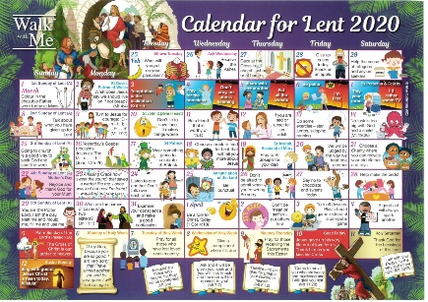

Thank you to the children in Miss Edge’s Class for their assembly on World Book Day.

Thank you to all the parents that were able to join us.

Congratulations to the children that received an award or certificate.

**Lent 2020** Please remember to take the time to look at the Diocesan ‘Walk With Me’ calendar that the children brought home for ideas. During Lent, we are all asked t o pray more, repent, support charities and to give something up or do something extra. See the grid (at the end of this newsletter) of all our key events during Lent including our fundraising efforts. It would be wonderful to see all members of our school community showing support as we mak e an extra special effort during Lent.

**Worker of the Week**

|  |  |  |  |  |  |  |  |  |  |  |  |  |  |  |  |  |
| --- | --- | --- | --- | --- | --- | --- | --- | --- | --- | --- | --- | --- | --- | --- | --- | --- |
| **Reception** | | **Year 1** | | **Year 2** | | **Year 3** | | **Year 4** | | | **Year 5** | | | | **Year 6** | |
| Hanna A | Benedict M Ava C | Bella S Olivia R | Olivia D | Milo P | Adam N | Noel M | Nadia Z | Molly L | | Imogen B | Praise T | | Alexander P | | Rere L | Charlie M |
| **Attendance: 95.9% Overall (total attendance for the week for the whole school) Our school target for this year is 97%.** | | | | | | | | | | | | | | | | |
| **93.1%** | | **96.3%** | | **94.8%** | | **95.4%** | | | **97.9%** | | | **96.3%** | | **97.5%** | | |
| **House Point Winner** | | | | **167 (points) (Winning House Overall – Rafael House 1241)** | | | | | | | | | | | | |
| **Class Attendance Winner** | | | | **Miss Gibson (Year 6)** | | | | | | | | | | | | |

**Grow a Pound for Lent**

****Year 5 and 6 have been given a challenge! They will be thinking about what they could do to grow a pound over Lent. Each child in Year 5 and 6 will be given a pound in an envelope and they need to think of something enterprising that they could do either by themselves or in a group to make money (the money will go to one of our Lenten charities). Ideas could be washing cars, baking cakes, running competitions through Lent…it is up to the children what they do though! It is always an exciting and fun activity to do so please do support them in their ideas. Your only rule is that at least £1 needs to be returned back to school 😊 The 3 children that raise the most money and grow their £1 the most, will get the opportunity of becoming Principals for the Day with me during the summer term.

**What’s your Goal**

As part of our RE curriculum, we have been learning about how Catholics support their wider global family. The CAFOD campaign for 2020 is called ‘What’s your Goal?’ which is aimed at supporting the people of the Amazon who are desperately trying to defend their rainforest. Shockingly, every 30 seconds an area of rainforest the size of a football pitch is destroyed due to deforestation. To help them in their crucial work, we will be holding a number of fun football-based fundraising events that the children can get involved in to help raise money.

On Friday 3rd April, the children will be invited to come to school in football kits/sports kits for a £1.00 contribution. Throughout the day, the children will take part in a range of activities including a penalty shoot-out competition, a ‘keepie-uppie’ challenge, finger football/phase football tournament.

In addition, on this day, all of the children from Nursery to Year 6 will be working in teams to complete a sponsored event - ‘The Football Dribbling Challenge’. As a school, the challenge is for the children to keep a football moving for the entire school day by dribbling it through a specially designed obstacle course. Each year group will have to do this for a designated length of time during the day. Sponsorship forms will be going out next week and we would be grateful for any contributions or support you could give. The 3 children that raise the most money will become Principals for the Day with me during the summer term.

**World Book Day**

What an incredible day we had yesterday celebrating World Book Day 2020! Our Book Day festivities started with a 'Booky Breakfast', where we nibbled on The Queen of Heart's Jam Tarts and Goldilocks 'Just Right' porridge. We snuggled up with a book and explored some wonderful stories with staff.

After this, it was time for our much-anticipated Vocabulary Parade. We were blown away by the inventiveness and creativity of the costumes this year - it was amazing to see the children exploring new vocabulary and challenging themselves to successfully illustrate their chosen word in costume form. The children strutted their stuff on the catwalk, sharing their costumes and choice of word - it was such an amazing way to allow us to learn more words and continue to spread our wings with developing our vocabulary.

During our World Book Day celebrations, we also had a year group vocabulary quiz where things got very competitive. Whilst all of the year groups exhibited an extraordinarily vast knowledge of language and words, it was Year Three who reigned supreme! We hope that parents and carers heard about all of the magical activities we had in store for the children for World Book Day this year and that the children's passion and love for reading was reinvigorated. Thank you also for helping the children prepare their costumes and props - they looked wonderful!

**The amount a child reads is the biggest factor affecting their academic success!**

**Secondary School Places (YEAR 6 Parents)**

All parents and children in Year 6 should have received official notification this week on which Secondary school you have been allocated either by e-mail or through the post earlier this week. We will be supporting Year 6 in transition to Secondary school over the next 5 months as we work in partnership with Cardinal Wiseman and the other secondary schools. If you have any immediate queries, then please speak to Mrs Taggart in the school office.

**Looking at Learning**

This week we hosted our 2nd “Looking at Learning.” We were blown away by the response of parents coming in to sit with your child and look through their books, talking about their learning with them. We hope you valued this special time with your children and that it informed you of what the children have been learning and how they are getting on. There will be a formal Parents Evening in April.

**Lent 2020 Cake Sales (Year 5/6 raised £109.00)**

During Lent we will be having a number of cake sales to raise money for our Lenten charities. Please support the event by making cakes or buying them from a shop. On cake sale days, children can bring in money to purchase cakes (30p/50p in price). Don’t forget! All cakes will be sold during break time and any left after school each Tuesday during Lent. Lent is a time for Almsgiving – raising money to give to charity – the cake sales are a one-off event for each phase during the four weeks we run this.



**Sports Relief is back**

Sports Relief is on Friday 13th March. This time we are asking you to help us take poverty and injustice in the UK and across the world by getting your kit on and raising some life-changing cash. Please support Sports Relief by dressing sport/football kits etc and bring in a donation of £1 for the charity. Have fun and help make a real difference…..It’s Game On! 😊

[](http://www.google.co.uk/url?sa=i&rct=j&q=&esrc=s&source=images&cd=&cad=rja&uact=8&ved=0ahUKEwix0qGTke_SAhXCWBQKHS3mDLwQjRwIBw&url=http://voicebo.com/LWbH7p&psig=AFQjCNHfUu-aYq5l_j3UFdRqdB557ajDcg&ust=1490444645228751)

**Class Prayer Times**

Our first class parent prayer time over the Lenten season will take place on Tuesday 10th March at 9am. The 2nd one will be on Tuesday 31st March at 9:00am in your children’s classrooms. We do hope you will be able to join us. We also have two Lenten Masses for KS1 and KS2 phases….see calendar of events on the next page.

[](http://www.google.co.uk/url?sa=i&rct=j&q=&esrc=s&source=images&cd=&cad=rja&uact=8&ved=0ahUKEwij7JbjzsbPAhWHrRoKHeI6ABwQjRwIBw&url=http://www.lesquennevais.sch.je/parents-community/parentmail.html&psig=AFQjCNG0UVDhaxUkRLc0LW2PW2XMj1THBw&ust=1475858298097861)**Parent Consultations**

On Tuesday 6th April 2020, we will be holding an appointment system for all classes for parents to meet with their teacher (1:00pm until 7:00pm in the school hall). Please make sure you make an appointment to see how your child is doing. All appointments will be made through our online system on Parent Mail. We will be sharing with you how your child is progressing and what their projected standard will be.



**Y2 and Y6 Parent Information Sessions**

On Thursday19th March 2020 (Y2 5:00pm) and (Y6 5:30pm) we will be holding information sessions for parents to inform you about the testing and assessment arrangements for the SATs (Statutory Attainment Tests) that your children will be taking in the summer term. The session will inform you about what your children need to know and do and how you can best support them at home. We will be providing parent information sheets to take away.

[](http://gracespace.org.uk/?attachment_id=3860)**Passover**

On Monday 30th March Year 3 will take part in their annual Passover meal. This is one of the first steps they make in preparation for their First Holy Communion where they think about different meals Jesus shared. The children will act out a traditional Passover meal and will enjoy all the symbolic foods such as Lamb, unleavened bread, egg and wine (which we will be substituting for grape juice!) Over the next few weeks, Year 3 will be learning about why Jewish people celebrate Passover and the significance of the different foods. If you wish to help with Passover please come to the office at 1:15pm. Alternatively, if you wish to join your child for the Passover meal it will begin at 2:00pm (hall.) We hope you can join us.

**SEN Parent Meetings**

**Calling all parents of children with SEN.** I would love for you to book an appointment with me on Thursday 12th March to talk about how we can continue to work together to support your child, what is currently in place and any additional support that they may require. I appreciate that you may have other commitments though the day, therefore I will be available between 8:30am and 7:00pm. Appointments are not necessary , just drop in at any point between these times. Please be aware that if you arrive at the same time as another parent there may be a short wait. If you are a parent of a child who is not on the register but you wish to raise a concern I would also like to see you so that we can work in partnership to ensure that your child can truly thrive. If this day is not suitable for you but you would like to see me, please pop into the office and we can arrange a mutually convenient time. I am very much looking forward to meeting with you. Mrs Cakebread.

**ARYPT- Ceilidh/ Live music with Sisters of Murphy**

Please see flyer for a social event that is coming up to raise funds for the Andrew Robinson Young Peoples’ Trust. Many pupils directly benefit from the money raised for this worthy cause.

Date      Saturday 14th March from 7pm

Venue   The Bull’s Head

Entry     Free (raffles will be held on the evening

****Don’t forget to keep playing Spelling Shed and TimesTables Rockstars

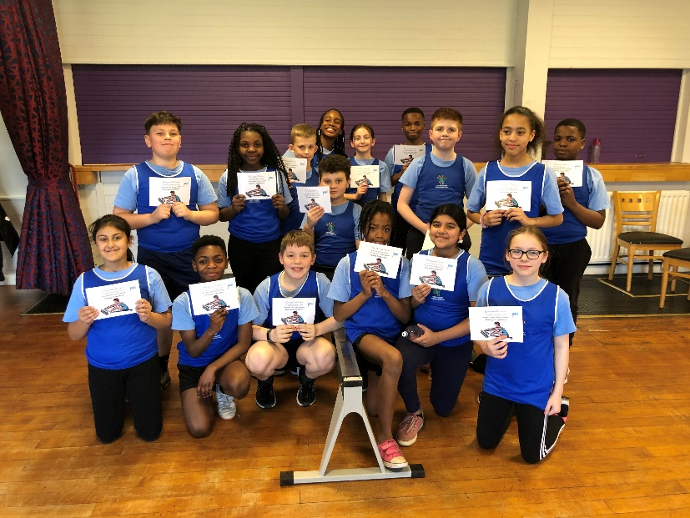**Sporting News**

On Tuesday, 16 children from Year 6 competed in a School Games rowing competition. They competed in two races, an individual row for 90 seconds and a 4 x 1minute relay. The grit and athleticism they all showed was incredible and we are extremely proud of them all. Rowing is a new sport for many of the children and it was fantastic how quickly they picked up the technique. The children all thoroughly enjoyed the afternoon 🙂

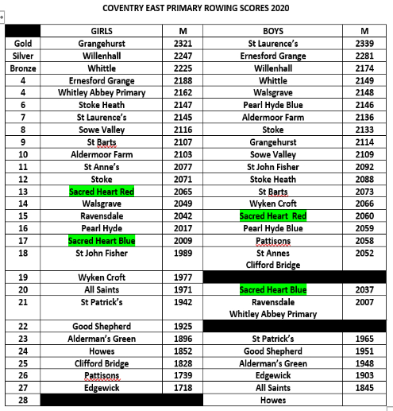

**Unfortunately, the boys cross country race has been cancelled for tomorrow. The field is still extremely water-logged. As soon as we find out the new dates we will parentmail these out.**

**Sorry for any inconvenience this may cause you and fingers crossed the weather will start to dry up!**

Congratulations to the year 4/5 boys and girl (Olivia) who won their match 2-0 against Wyken Croft on Thursday. The team showed amazing team spirit and we look forward to seeing them develop and grow.

**Key dates over the Lenten Season:**

|  |  |  |  |  |  |
| --- | --- | --- | --- | --- | --- |
| **Lent 2020** | **Monday** | **Tuesday** | **Wednesday** | **Thursday** | **Friday** |
| **Week beginning**  **9thMarch** | Sports Relief (all week)  Science Week  Konflux Theatre - Mrs O’Malley’s Class | Year 3 and Year 4 to bring in cakes for their Cake Sale (breaktime/after school)  Lent Parent Prayer Time  Whole School – parents to come into the classrooms (9:00am) |  | Konflux Theatre - Miss Cummiskey’s Class | Miss Thomson’s Class Assembly (Reception) “Sports Relief”  Children to dress up wearing sporty clothes – donation of £1 |
| **Week beginning**  **16th March** | Quasimodo Production for Year 4/5/6 (Hunchback of Notre Dame) | Year 1 and Year 2 to bring in cakes for their Cake Sale (breaktime/after school) | Sparks visit to Year 4  KS1 Lent Mass in School  (Father Tony)  9:00am Parents Welcome | Yr2 SATs parent’s meeting 5:00pm  Yr2 SATs parent’s meeting 5:30pm | Miss Cummiskey Class Assembly (Year 5) Mother’s Day |
| **Week beginning**  **23rd March** | Class Photographs  (Winter Uniform) | Year Nursery/Reception to bring in cakes for their Cake Sale (breaktime/after school)  St. Oscar  Romero Feast Day | Alton Castle – Year 5  KS2 Lent Mass in School  (Father Tony)  9:00am Parents Welcome | Alton Castle – Year 5  Mousike Ensemble  Performance Yr1  Year 3 First Holy Communion Parent Meeting (School) 6:00pm | Alton Castle – Year 5  Mrs Davies’ Class Assembly (Year 6) St. Oscar Romero |
| **Week beginning**  **30th March** | Mousike Ensemble  Performance Yr5  Passover Year 3 (hall) 2pm  Reception Snuggle up with a book – 3:30pm | Lent Parent Prayer Time  Whole School – parents to come into the classrooms (9:00am) | Warwick Castle Trip – Yr 1 | Whole School Open Morning – parents invited to come and spend the morning with their children – looking at how we teach reading – 9:00am – 10:30am | Year 5 (joint) Class Assembly Alton Castle Residential  Dress up sporty (competitions throughout the day) – bring in £1 |
| **Week beginning**  **6th April**  **Holy Week** | “What’s your Goal” sponsorship forms to be returned | | | | |
| Nursery AM/Reception/Yr 1 Achievement Awards (9am)  Parent Consultations (school hall) 1:00pm – 7:00pm | Year 2/3/4  Achievement Awards (9am)  Nursery PM Achievement Awards (3:00pm) | Year 5/6  Achievement Awards (9:00am)  Reception Vision Screening | Year 4 Lenten Reflection in school (9:10am) Parents Welcome  Break Up from School for  Easter Holidays | Good Friday  School Closed  Easter Holidays |

**Extra-Curricular activities/clubs – ** Spring Term 2020 ** (please collect your children at 4:20pm for all clubs)**

|  |  |  |  |  |
| --- | --- | --- | --- | --- |
|  | **Monday** | **Tuesday** | **Wednesday** | **Thursday** |
| **Led by CV Life**  **To book - 024 76308244** [**NBWILSON@cvlife.co.uk**](mailto:NBWILSON@cvlife.co.uk) | Ball Games – R/Yr1/Yr2 | Gymnastics - R- Yr6  Football – R-Yr2  Netball – Yr3-Yr6 | Musical Theatre  Group 1 – R- Yr2  Group 2 – Yr3 – Yr6  KS2 Football – Yr3 – Yr6 | Playground Games R – Yr5  Dance (invitation only) Yr4-Yr6 |
| **Led by School Staff** | Cross Country - Yr3 to Yr6 | N/A | Netball Club – Yr5 – Yr6 | Boys Football Club – Yr6 |
| **Upcoming fixtures** | N/A | N/A | N/A | Girls’/Boy’s individual and team event - Cross Country (Bablake Playing Fields) |

**NEXT WEEK – British Science Week / Sports Relief**

**Week at a glance**

|  |  |  |
| --- | --- | --- |
| **Date** | **Time** | **Activity** |
| **Value and Virtue – Faith-Filled and Hopefully** | | |
| Sunday 8th March | 10:30am | 2nd Sunday in Lent (Parish Mass at Sacred Heart) |
| Monday 9th March | Morning  All Day  Morning | Guitar Lessons  Year 5 Mrs O’Malley’s Class – Konflux Theatre visit (Shakespeare)  Hearing Tests (Reception) |
| Tuesday 10th March | 9:00am  Morning  Break Time  3:00pm | Lent Parent Prayer Time (parents invited – wait by your child’s door)  Guitar, Piano and Violin Lessons  Cake Sale (Year 4/Year 3 to bring in cakes) children to bring in money!  Lent Parent Nursery PM Prayer Time |
| Wednesday 11th March | N/A | N/A |
| Thursday 12th March  **Year 1 to Mass** | All Day  Morning  3:20pm | Year 5 Miss Cummiskey’s Class – Konflux Theatre visit (Shakespeare)  Year 4 Royal Albert Hall Choir Rehearsal (in school)  Mad Science Club |
| Friday 13th March | 9:00am  3:15pm | World Book Day Assembly (Year R Miss Thomson) – Parents Welcome  Spelling Shed/Times Tables Rockstars updated |
| Sunday 15th March | 10:30am | 3rd Sunday in Lent (Parish Mass at Sacred Heart) |

**I hope you have a wonderful weekend.**



**Mr P Madia**

**Principal**